Republic of the Philippines

Tarlac State University

**COLLEGE OF COMPUTER STUDIES**

Tarlac City, Tarlac

Tel. No. (045) 6068173

**"NEEDS ASSESSMENT OF AN ONLINE COUNSELING SYSTEM FOR TSU CCS"**

Submitted by:

Justine M. Austria

Kent Louies J. Corpuz

Jimwel M. David

Juan Antonio M. David

Arjen Simbillo

Submitted to:

**Mr. John Cedric G. Asprer**

Date: October 22, 2023

A.Y 2023-2024

**ABSTRACT**

This study focuses on the College students that are always faced with diverse mental health problems. Nowadays, they can easily access online counseling services to reduce their problems. This research determines the most desired component to develop the online counseling program which aims 1) to study the needs to develop an online counseling program, and 2) to rank the priority needs for developing this program. Participants were 50 students who are studying in Tarlac State University. This study uses qualitative research as the methodology and surveying through online as the primary way of gathering data for the results of the study.

**TABLE OF CONTENTS**

Introduction.…................................................................................................................... 4

1.1 Background of the Study.…............................................................................. 4

1.2 Objectives of the Study.…............................................................................... 4

1.3 Significance of the Study.…............................................................................ 4

1.4 Scope and Limitation.….................................................................................. 5

1.5 Definition of Terms.…..................................................................................... 5

Review of Related Literature.…........................................................................................ 5

2.1 Foreign Literature.…........................................................................................ 5

2.2 Foreign Studies.…............................................................................................ 6

2.3 Local Literature…............................................................................................ 6

2.4 Local Studies.…............................................................................................... 7

Methodology.…................................................................................................................. 8

3.1 Methods in Data Gathering.…......................................................................... 8

3.2 Sources of Data.…........................................................................................... 8

Results and Discussion.….................................................................................................. 9

Conclusion.…................................................................................................................... 10

5.1 Conclusion.…................................................................................................. 10

5.2 Recommendations.…..................................................................................... 10

**TABLE OF FIGURES**

Table 1. …......................................................................................................................... 9

Table 2. …......................................................................................................................... 9

Table 3. …......................................................................................................................... 9

Table 4. …......................................................................................................................... 9

Table 5.…........................................................................................................................ 10

Table 6.…........................................................................................................................ 10

**1 INTRODUCTION**

### Background of the Study

The evolution of the Internet makes significant changes in human life, including the influence on mental health (Sukmawati, 2019). There is an integration between the Internet and counseling, also known as online counseling, to treat mental health problems. It is a novel concept that grows in popularity over time because, in the past, people only received face to face counseling from a counselor. However, in the modern era, technology has been combined with the concept of therapy, resulting in treatment or counseling delivered via the Internet. Counseling is delivered via phone, email, instant messaging, chat, and video conferencing. At the same time, many international researchers define this term in a variety of ways, such as online counseling, cyber-counseling, e-counseling, web-counseling, tele counseling, computer-mediated counseling, distance counseling, and so on. The information technology system is used as a communication channel, which has been classified into five types: telephone-based, email-based, chat-based, video-based, and social network-based services. Through these channels, the counselor and the client (the counselee) are at different places and communicate via the Internet (Richard & Viganó, 2013; Zainudin & Yusop, 2018).

Based on increasing Internet access statistics, it is becoming more convenient to expand e-mental health services around the world to remove treatment barriers (Navarro, Bambling, Sheffield, & Edirippulige, 2019), including a survey of Thai people using social networking services. In 2020, it was reported that Thai people owned 52 million social network users, representing 75% of the Thai population (DIGITAL 2020: Thailand, 2020: Online). Students or university students are the most internet users who used approximately 10 hours and 50 minutes per day (Office of Policy and Strategic Affairs, Electronic Transactions Development Agency, Ministry of Digital Economy and Society, 2020).

### Objectives of the Study

This study aims to identify 1.) whether there is a need for Students of TSU-CSS to Develop an Online Counseling System. 2.) whether there is a need for Student of TSU-CSS to use an Online Counseling System.

### Significance of the Study

The result of this study will benefit:

**Students**. the students will be the main benefactor of this study to help them from possible mental health issues.

**Faculties**. this study will help the faculties to be aware of what is happening to their students and possibly give their student guidance on their mental health.

### Scope and Limitation

The participants used in this study consisted of students of CSS from Tarlac State University. A total 50 student participated in the survey. This study is limited by a period of time and might affect the gathering of data from the participants of the survey.

### Definition of Terms

To further understand this study, here are the different terms used.

**Mental Health** - is a state of mental well-being that enables people to cope with the stresses of life, realize their abilities, learn well and work well, and contribute to their community. It is an integral component of health and well-being that underpins our individual and collective abilities to make decisions, build relationships and shape the world we live in.

**Mental Health Services** - are interventions designed to provide the maximum reduction of mental disability and restoration or maintenance of functioning consistent with the requirements for learning, development and enhanced self-sufficiency.

**Counseling** - a person endeavors to help another to understand and solve his adjustment problems. The provision of assistance and guidance in resolving personal, social, or psychological problems and difficulties, especially by a professional.

**Counselor** - a person trained to give guidance on personal, social, or psychological problems.

**Counselee** - the person who is being counseled.

**REVIEW OF RELATED LITERATURE**

This chapter represents the study of the relevant literature and studies that the researcher considered in strengthening the importance of the present study. It also presents the synthesis of the art to fully understand the research for better comprehension of the study.

### 2.1 Foreign Literature

Here is a review of the views of some of the writers who said that Assessment of an Online Counseling System could reduce depression and anxiety to promote well-being of youths and university students effectively so that they created Artificial intelligence (AI) to look after university students who had mental illness dues to the traumatic event (Post Traumatic Stress Disorder (PTSD) or depression. AI included 1) CBT chatbot: the form of a conversation that transmitted through CBT therapy or Woebot for reducing student depression and anxiety. 2) Meetings for treatment and privacy: a consultation service about mental health and physical health by meeting psychiatrist online which reduced a traveling time and protected privacy. (Lovejoy, Buch and Maruthappu, 2019).

Based on the situation of the Coronavirus disease 2019 (COVID-19), relevant agencies such as the Centers for Disease Control and Prevention and the World Health Organization (WHO) advise people to live separately, keep physical distance, wash their hands frequently, and keep the environment hygienic to reduce germ spread (American Counseling Association (ACA), 2020). The COVID-19 pandemic has had a profound impact on people's lives. Both physical and emotional well-being are affected. In terms of physical health, it leads many individuals to become ill and die, making medical personnel's jobs substantially more difficult. It also has social rejection and discrimination. The mental health implications can last longer and have a greater prevalence than the pandemic (Ornell et al., 2020).

### 2.2 Foreign Studies

As a result, since the coronavirus pandemic, there is an urgent need to provide online counseling to university students Mahasarakham University has four crucial units responsible for the care of students' mental health and mental health problems, which are as follows: (1 Counseling Work, Student Affairs Division, provides care and sets policy in terms of counseling students who have problems and need help.) (2 Southaven Hospital, run by a team of psychiatrists, psychologists, and psychiatric nurses, works under the supervision of the Faculty of Medicine to provide mental health care and treatment to students.) (3 The Faculty of Nursing's Mental Health Counseling Clinic) and (4 The Faculty of Education's Psychological Excellence Center.) (Tuklang and Yurayat, 2021).

(Khantichitr, Promwong, Keawmanee, and Charoenukul, 2021) claimed in their study that a person who has a good health belief model will engage in appropriate health prevention behaviors, especially during the COVID-19 pandemic situation. Attitudes are the opinions, beliefs, and feelings of a person based on learning and experience, which are stimuli for the person to behave. Attitudes could be positive or negative. Positive attitudes towards online counseling drive individuals to be more likely to seek online counseling.

### 2.3 Local Literature

As a result, the usage of TR increased significantly during the pandemic. With Facebook Messenger as their preferred platform, the majority had already been using it for more than a year. The typical sessions were an hour long and employed a mix of synchronous and asynchronous techniques. A face-to-face therapy session would have cost more than the professional price. All of the respondents had favorable opinions on TR. A developing nation like the Philippines does not appear to have the same level of TR interest, awareness, or adoption among PTs as developed nations with well-established telemedicine systems and courses dating back to before the epidemic. For physical therapists (PTs) to improve their knowledge, abilities, and experiences using virtual reality, having positive attitudes about implementing telehealth innovations into clinical practice and teaching may be a good place to start. (Sosa, Leochico and Rimando, 2023).

The majority of the research, which primarily focused on mental therapies, were discovered to be carried out overseas. A few papers also included physical interventions. The local implementation of an online wellness program may not be the same in various countries, including the Philippines, like any other health and behavioral initiatives. Local contextual factors like poor internet connectivity, a lack of study spaces at home, power outages, weak infrastructures, high internet costs, various adjustments in learning styles, domestic responsibilities and financial concerns, and possibly poor communication with people due to technological use and availability constraints may act as implementation barriers. Despite these obstacles, the Philippines is still regarded as one of the most active nations when it comes to using social media and the internet. (Escuadra et al., 2023).

### 2.4 Local Studies

This research centers on the experiences of guidance advocates through tele-counseling, aiming to support holistic learner development. (Gallardo and Chavez, 2022) Emphasize the scarcity of research exploring counselors' experiences and perceptions regarding wellness programs, well-being, self-care practices, and retention, highlighting the need for further exploration. Focused on the concept of "transactional distance," the study delves into the psychological gaps between students, instructors (guidance advocates), and course content in the context of distance education (Moreno et al., 2021; Stapleford et al., 2020; Nelson, 2019).

The rise and the impact of information and communications technology (ICT) have had a tremendous effect on the field of online counseling, particularly Internet innovation. Through the Internet today, especially during the COVID-19 outbreak, everyone who works in the mental health field can provide free online/cyber counseling services by advertising it as a form of humanity towards others. The history of computer and Web utilization in counseling has added another level to the work of pastoral/spiritual counselors or psychologists, especially during the COVID-19 pandemic outbreak. This will enhance information about modern treatments, as well as giving the historical context for the increasing use of online/cyber counseling. The current pastoral/spiritual counseling programs need to be upgraded to reflect the changes within the counseling field and the requirements of students. (Situmorang, 2020).

**METHODOLOGY**

### 3.1Methods in Data Gathering

**3.1.2 Research Design**

The research design for this study could be a survey based study where in Tarlac State University students are asked to report their experiences on "Needs Assessment of an Online Counseling System for TSU CCS". An attempt to determine the opinions of the respondents on the impact of intelligent apps to their studies.

**3.1.3 Population and Sample**

The target population for this research title would the 50 students of the College of Computer Studies in the Tarlac State University. The target population should be clearly defined to ensure that the research findings are relevant to this specific group.

**3.1.4 Research Instrument**

The Research Instrument used in this study is Google Forms is a commonly used online survey tool that can be used to collect data for research studies. It allows the researcher to create questions, multiple choice options, and other types of response formats, and then share the survey with participants via email. The data can be collected and analyzed automatically by Google Forms or exported to another program (such as Excel) for further analysis. Using Google Forms would be an appropriate and efficient way to collect survey data for a study on the "Needs Assessment of an Online Counseling System for TSU CCS"

**3.2 Source of Data**

**3.2.1 Primary Source of Data**

Primary sources in this study on the "Needs Assessment of an Online Counseling System for TSU CCS" indirect observation: including online surveys and google forms.

**3.2.2 Secondary Source of Data**

Secondary sources include existing data, literature reviews, surveys of transportation providers, and online community analysis, which provide additional context and background information of this study.

**RESULTS AND DISCUSSION**

|  |  |  |  |  |
| --- | --- | --- | --- | --- |
| Very Important | Important | Neutral | Not very important | Not Important |
| 40 | 5 | 5 | 0 | 0 |

*Table 1. Importance of the availability of online counseling.*

In the question “How important is it for you that the online counseling system is available in your college?”, out of 50 CCS students who participated in the survey, 40 voted very important, 5 voted important and 5 voted neutral.

|  |  |  |  |
| --- | --- | --- | --- |
| Computer/Laptop | Smartphones | Tablet | Other |
| 15 | 15 | 14 | 6 |

*Table 2. What devices does the participant use.*

In the question “What Devices do you have access to for online counseling?” out of the 50 students who participated in the survey, 15 students voted for Computer/Laptop; 15 students voted for Smartphones, 14 voted for Tablet, and the remaining 6 students who voted for others specified that they prefer Face to Face counseling

|  |  |  |  |  |
| --- | --- | --- | --- | --- |
| Very Important | Important | Neutral | Not very important | Not Important |
| 11 | 3 | 7 | 15 | 14 |

*Table 3. Importance of privacy and confidentiality for the participant.*

In the question “How important is user privacy and confidentiality to you in an online counseling system?” out of the 50 students who participated in the survey, 11 students voted very important, 3 students voted important, 7 students voted neutral, 15 students voted not very important, and 14 students voted Not important

|  |  |  |  |  |  |
| --- | --- | --- | --- | --- | --- |
| Live Chat | Group Counseling Sessions | Audio Counseling | Video Counseling | Self-help resources | other |
| 15 | 18 | 7 | 5 | 5 | 0 |

*Table 4. What features does the participant would like to see.*

In the question “What features would you like to see in an online counseling system?” out of the 50 student participants in the survey, 15 voted for Live chat, 18 voted for group counseling sessions, 7 for audio counseling, 5 for video counseling, 5 for self-help resources

|  |  |  |  |  |
| --- | --- | --- | --- | --- |
| 1(Not Important) | 2 | 3 | 4 | 5(Very Important |
| 0 | 0 | 10 | 10 | 30 |

*Table 5. Importance of accessibility to the participant.*

Based on the student rating scale on 1 to 5, asking “How important is it for you that online counseling system is accessible 24/7?” Out of the 50 students who participated in the survey, The table states that all participants agree that 24/7 access to counseling system is very important.

|  |  |  |  |  |
| --- | --- | --- | --- | --- |
| Academic Stress | Personal Relationships | Mental Health Concerns | Career guidance | Other |
| 15 | 5 | 15 | 10 | 5 |

*Table 6. Issues and topics for counseling.*

In the question “What types of issues or topics would you seek counseling for online? Out of the 50 student participants, out of the 50 students who participated. 15 voted for academic stress, 5 for personal relationships, 15 for Mental Health Concerns, 10 for Career guidance and the remaining 5 students chose other.

**CONCLUSION**

### 5.1 Conclusion

Mental health incorporates to our emotional, psychological and social being as well. So accordingly, it is really essential to take care of our mental health too. It is much more important to look after our mental health in order to function suitably as a human being. For students, it is principal because it disturbs how they learn, how they participate and how they cooperate with others. Counseling plays a determining role for students. It helps students to refresh their minds and open to someone what bothers them regarding academics, personal problems and other related complications such as families.

To sum up everything that has been stated in our Study, it helped a lot of students to be more active and participate in class. Correspondingly, it helped a lot of students to enhance their moods, develop their communication and relationship towards other people, boost self-esteem and resilience. Unlike before without counseling, students want to be alone and mind their own businesses. But now, students are able to speak for themselves and learned how to approach people in an appropriate way. With the help of online counseling, it helped students to be heard and understood.

### 5.2 Recommendations

This study revealed different types of dilemmas that students encounter. Therefore, here are ways to maintain student’s mental health:

1. The investigation looked at the number of students who encounter such problems, and for that reason, counseling must be provided once a month.

2. The aim of this project is to create a harmonious environment and to help students overcome what obstacle they are up to.

3. Since anxiety and depression are one of the most problems of every individual, which is commonly caused by Academic Stress and Mental Health Concerns. It is important that online counseling should be pushed through in order for the students to share their insights.

4. The researchers recommend is to give significance to counseling and have a specific tool/application that will be confidential for the student and counselor only.

5. The researchers advocate that counselors must attentively attend online counseling once a month to prevent negligence concerning mental health issues.

**REFERENCES**

P. Chatterjee and M. Esposito, Artificial Intelligence in Healthcare and COVID-19. Elsevier, 2023.

<https://ccforum.biomedcentral.com/articles/10.1186/s13054-018-2301-9>

(Ornell et al., 2020) The COVID-19 pandemic and its impact on substance use: Implications for prevention and treatment.

<https://www.sciencedirect.com/science/article/pii/S0165178120309033>

Tuklang, S., & Yurayat, P. (2021). The Confirmatory Factor Analysis of Psychological well-being of

Mahasarakham University Students. Journal of Social Science and Buddhistic Anthropology

<https://so04.tci-thaijo.org/index.php/JSBA/article/view/252868>

(Khantichitr, Promwong, Keawmanee, and Charoenukul 2021) Undergraduate Students’ Attitudes towards

Online Counseling since the COVID-19 Pandemic

<https://eric.ed.gov/?id=EJ1335206>

(Ken Erbvin R. Sosa, Carl Froilan D. Leochico and Christian Rey D. Rimando, 2023) A Webbased Survey on the Telerehabilitation Knowledge, Attitude, and Practice of Physical Therapists

In a Developing Country during the COVID-19 Pandemic: An Analytical Cross-sectional Study

<https://actamedicaphilippina.upm.edu.ph/index.php/acta/article/view/6664>

(Catherine Joy Escuadra,, Barbra Nava, Arlene Chiong Maya, Katrina Jarobel, Neil Aningalan, Llana Duya,

Marco Francisco III, Julia Villocillo, Jan Ramos, Darlene Lim, Beatriz Borhillo, John Wycoco

2023)Evaluation of an Online Physical and Mental Wellbeing Program for UST CRS Students: A Feasibility Study Protocol

<https://pjahs.ust.edu.ph/wp-content/uploads/2023/02/8_Escuadra.pdf>

((Moreno et al., 2021; Stapleford et al., 2020; Nelson, 2019)Guidance Advocates and Their Online

Counseling Experiences: An Interpretative Phenomenological Analysis

<https://jrtdd.com/index.php/journal/article/view/1723/1214>

(Situmorang, 2020) Online/Cyber Counseling Services in the COVID-19 Outbreak: Are They Really New?

<https://journals.sagepub.com/doi/pdf/10.1177/1542305020948170>

**CURRICULUM VITAE**

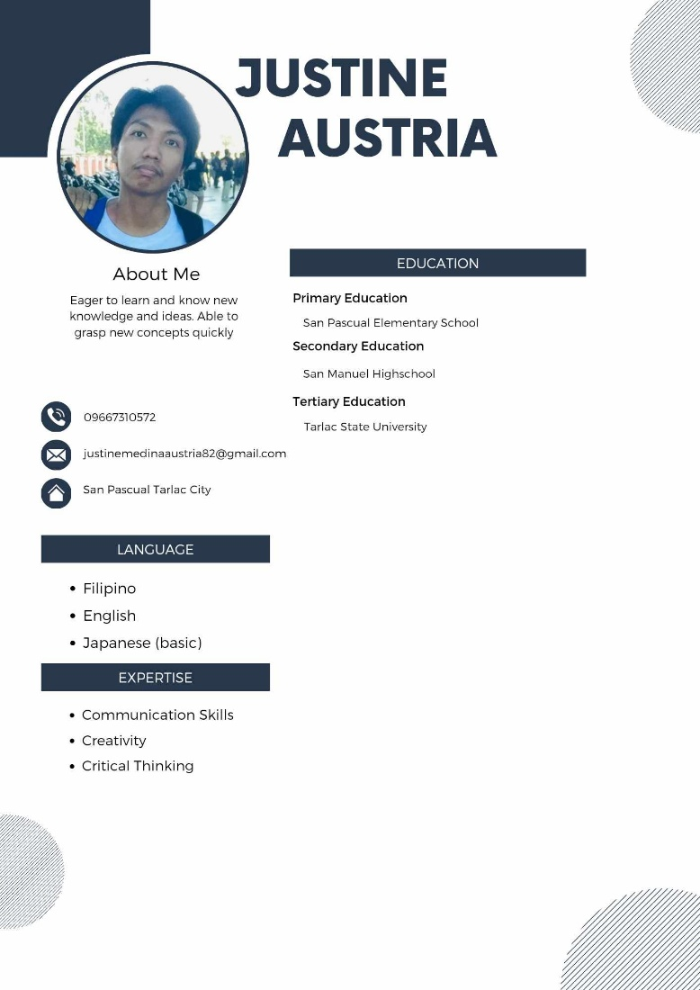

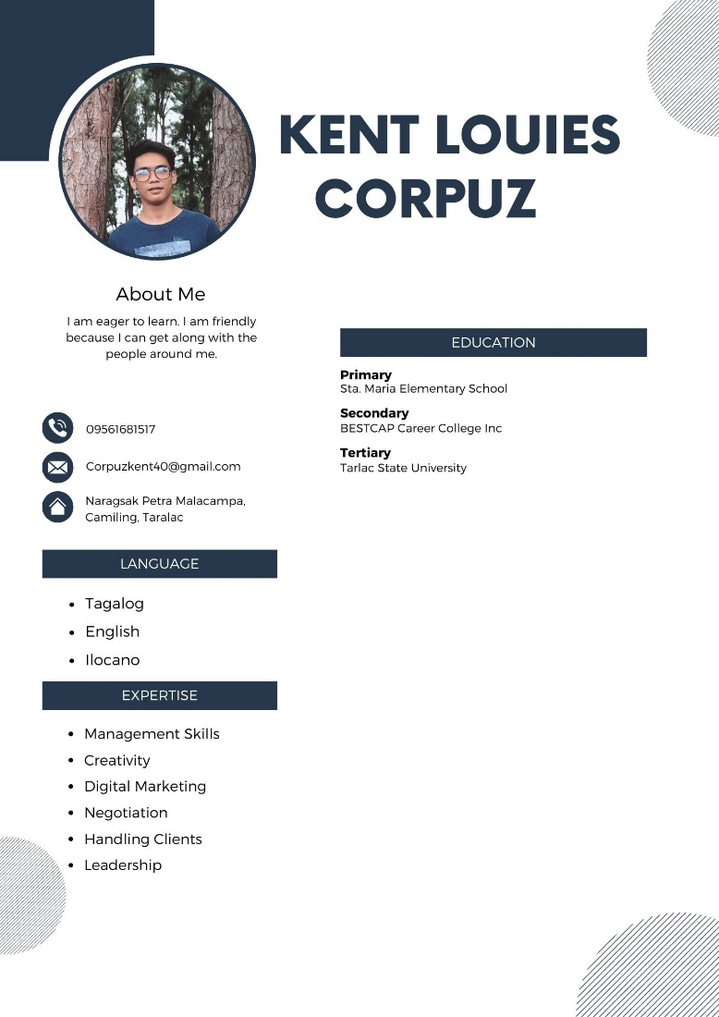

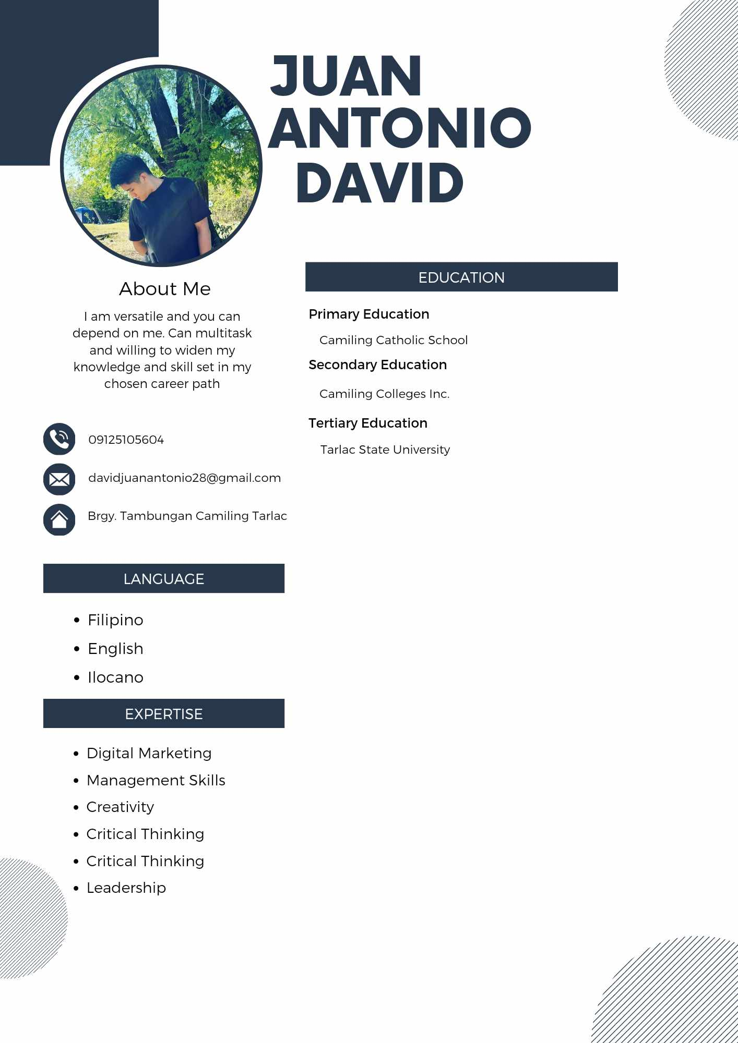

**DOCUMENTATION**

